## **“The Messenger” 1-Page GDD**

*“Deliver this message and save us all!”*

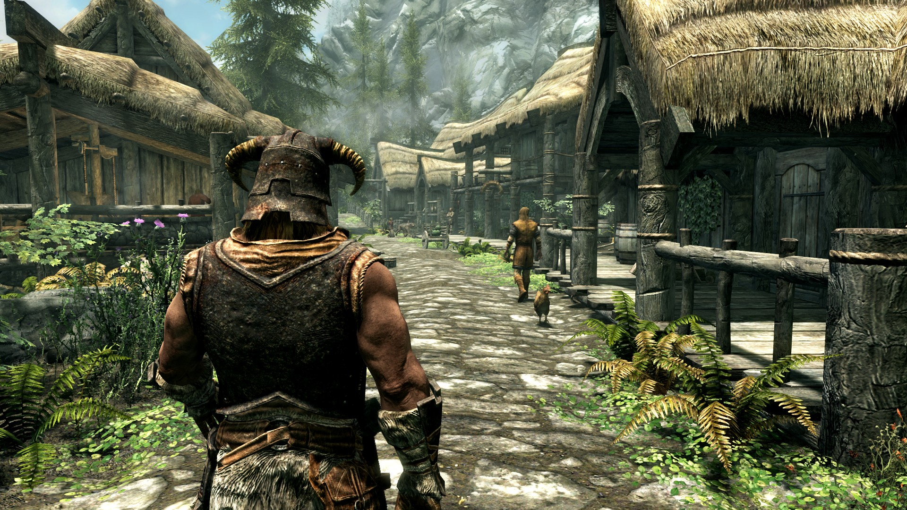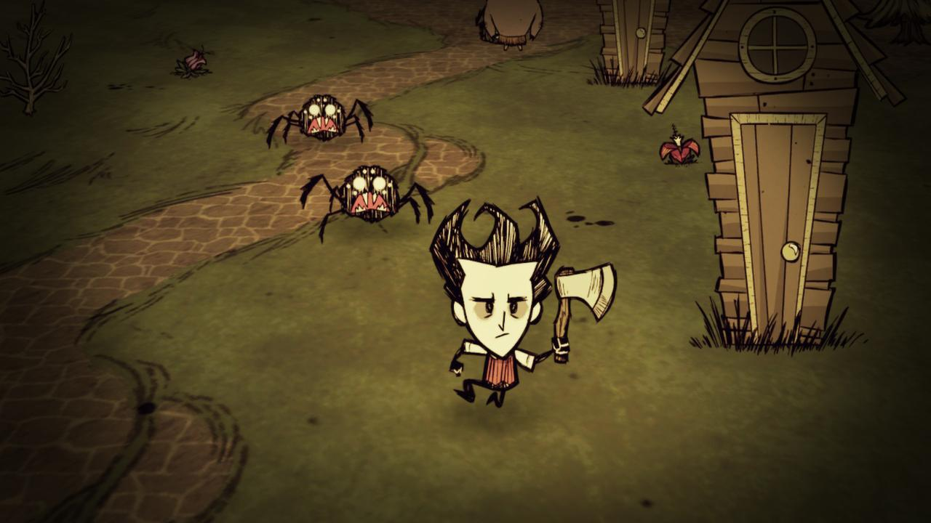

**Genre:**  Open-world RPG  
**Target Audience:** Mature

**Controls:** Mouse and Keyboard, Control Pad

**Thematic Setting:** Medieval Fantasy

**Tech Stack:** Unity 5+, Blender (or 3DS Max), Gimp / Photoshop, Audacity

**Platform(s):** PC (Steam, GOG)

**Game Moment (moment-to-moment gameplay):** Walking along a semi-linear path through various themed areas, interacting with npcs and vendors, basic combat (hitting and taking damage)**,** gathering resources

**Game Summary:** A plague has devastated your village and you have been tasked with delivering a message to the king in order to request aid. The journey to the castle is long and treacherous and will require you to manage your equipment and make moral choices. You, too, carry the plague, so be careful who you interact with.

**Core Player Experience:**

**Central Theme:** Race against time, Man vs. Man, Man vs. Nature?

**Design Pillars:** Resource management, moral choices, combat

**Anticipated Steam Early Access Launch date:** 12/15/2018

**Feature Development Priorities:**

* Freely-explorable open world
* Resource management mechanics and stats (e.g. weight limit, plague level)
* Interactable NPCs, obstacles, and hazards

**Comparative Products:** Don’t Starve, Skyrim, Papers Please, Oregon Trail